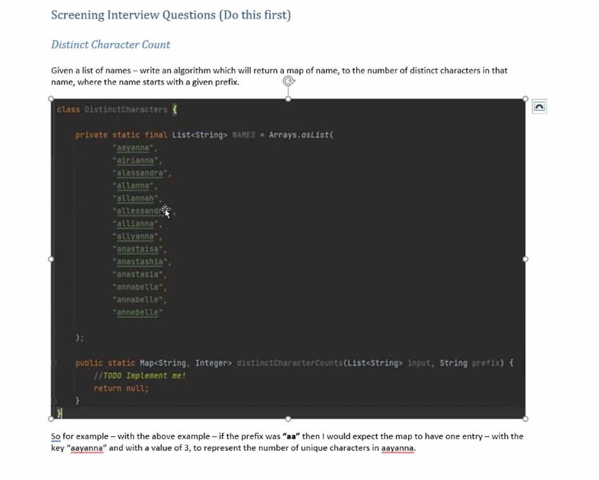Java stream

Structuring your coding project in java

Composition – what it is and why we use it?

How we can make Java code thread safe?

Brief description of a devops & CI/CD approach

What test do you write for your code?

Databases: how does the index work?

**Question Bank**

**L2 panel**

**OOPS & Lang fundas**

**1** How to write immutable class,why do we need them and rules to create mutable class, cross questions.

**2** write a immutable class employee wth id, name and Address. then cross questions like, how will you write getter, setter and constructor so that immutability of this class is preserved.

**3** Type casting(implicit & explicit) cross questions

**4** create a singleton class and cross questions on it---- like i have 4 containers so how many singleton objects will be created.

**5** How to make Singleton as Lazy ,egar loading & thread-safe . Demostrate with code

**6** what is inheritance and encapsulation? interfaces and abstract classes

**7** Overloading and overriding, some cross questions, Co-varient return type

**8** Explain final keyword, with class, method and variable

**9** use of protected access specifier, some cross question

**10** What are different types of Class -Loaders

**11** What is Marker Interface ? How to use cloning ? What is diff b/w shallow cloning/deep cloning

**12** What is diff b/w String vs StringBuffer vs String Builder ?

**13** What is Method Hiding ?What is different use of static in Java?

**14** What is Memory Management & call by value/reference in Java?

**Exception handling**

**1** Exception Handling in java, Complete hierarchy of exceptions,Types of exception (Cross Questions)

**2** Checked vs unchecked Exception

**3** What is Exception handling with method overriding rules in Java, explain with code ,cross questions on code

**4** if we write return statement in catch block then will finally execute?

If we write System. Exit then will finally block execut

**5** What is try-with-resource in Java? Explain with code

**6** Diff b/w ClassNotFoundException vs NoClassDefFoundError? Exception vs Error & cross question

**Multithreading**

**1** What is multithreading (cross-questions) ? What are Thread States ,explain in details, ways to create thread in java?

**2** What is concurrency api in java (cross-questions).

**3** How many types of locks,object level lock, class level lock, synchronized ,Internal architecture of synchornized block,

**4** what are reentrant lock advantages

**5** Difference Between CountDownLatch And CyclicBarrier in Java

**6** What is Semaphore ? Explain with real-life example .

**7** Explain Excecutor services

**Collections**

**1** What all collection data-structure used in your project

**2** Internals of HashMap,what happen if 3 objects have same hashcode in hashmap.

**3** When to use Linkedlist and ArrayList

**4** Concurrenthashmap internal working?difference between concurrenthashmap and synchronnizedmap in collection method & counter questions

**5** where you used hashmap & concurrenthashmap in ur previous project ? how concurrent is handled in iterator & counter questions?

**6** Difference between LinkedHashMap and Treemap and their implementation.

**7** How to merge two sorted list into a single list

**8** Map<Employee, String> -- given, hash-code is overridden, entered three elements in map, what will be the size of map.

**9** class employee of (name and dob), we have a list of 1000 employee, which data structure we use if we need to find the number of employee

having dob at a particular date.

**10** what is priority queues?

**11** What is Generics in Java?

**Subtotal**

**Java 8**

**1** Java 8 basic questions, stream api, map , filter, reduce ...etc

**2** default & Static method in Interface ,explain the advantage

**3** what is functional interface ? How to use functional interface in Lamda expression.What is Optional class ?

**4** What is Method references ,Types of Method references

**Subtotal**

**Spring/Boot**

**1** how you are managing application.properties file for different type of data in SpringBoot?

**2** Type of scope in spring

**3** What are profiles in spring boot, and cross questions on it.

**4** Basic questions on Rest api related to project

**5** Spring Aop (how did you use in your project) ,Annotation @Aspect, point cut expression, @Before, @After, @AfterReturning, @After throwing, @Around

**6** Spring boot advantages ,Annotation @Qualifier, @Primary, @postconstruct and @predestroy their uses and scenario-based questions

**7** How did you handled exception in rest api ?

**8** Given a jar, having some class how to use that its sendmail() method in our springboot project.

**Problem solving/DS**

**1** write a program to find most repeating

ababbbcdadaca

output: b

**2** write a program for finding max and min number

i/P: 7, 15, 5, 8, 88, 21, 89

**3** given two sorted arrays a= {20,35,40,60,70} b ={10,15,45,90,100} . write a program which will give me the third array in sorted order and will formed with these two arrays.

**4** [({})] -- return true

[{(]}) -- return false

there will be input of the string either of the two, create a method which will return true or false,

**5** scenario based questions

we have the list of stocks in which we are maintaining last 10 prices, also we can get the latest price for every 1 secs by third party api(class), how to handle this scenario

**Miscellaneous**

**1** have you worked on jms? questions on queues and event

**2** have you worked on kafka? Cross-Questions

**3** have you worked on microservices ? Cross-Questions

**DB**

**1** Where vs Having clause

**2** Indexing internals, including data structures, types of indexes - clustered vs non-clustered

**3** DB performance tuning, including use of explain plan and how db engine processes queries

**4** Types of SQL joins - Inner, Outer, Self, Equi, Non-Equi, Cross etc with examples

**5** Normalization and its forms - why normalization, denormalization. Trade offs

**6** Table relationships: 1:1, 1:N. How to implement M:N

**7** Basic concepts - Trigger, Synonym,Cursor etc

**8** View vs Materialized View

**9** Stored proc vs Function

**10** Types of SQL statements: DDL, DML, DCL

**11** Write query to eliminate duplicate employee records

**12** Top N query

**13** Correlated subquery with example

**14** Truncate vs Delete; difference across DB implementations

**15** Handling null using NVL, NVL2, COALESCE

**16** Tuning a slow correlated subquery

**17** Transaction - ACID properties, handling txn in Distributed DBs - patterns

**18** Isolation levels

**19** sql query for emplyee table(columns - emp_id,emp_name, manager_id, salary), list out all the manager which has more salary than the employee

**20** Delete all employee records whose name starts with A and salary between 1000 and 2000

**21** student table -- student id, student -name

course table -- courseid,course name

mapping table -- studentid, course id

# tables re given

write sql , which will return courseid and number of student enroll for that course.

**22** table1 employee = id, emp_name, dept_id

table2 department = id, dept_name;

print emp_name, dept_name null have to be allowed

**23** SQL query to find employee(s) with highest or Nth highest salary

**24** employee table(emp_id, slary, depart_id, emp_name) department table(depart_id, depart_name), fetch the emplist for the maximum salary of each department

**25** Retrieve count of all unique names (after removing duplicates) in the employee table

**26** Find all employees that do not have managers

**27** Employee(id,name,salary, mgrId)

EmployeeContact(id,phone)

Retrieve phone numbers of all employees without managers

**28** Customer(id, name, city, grade, salesman_id)

Write a SQL query to find those customers who belong to neither the ‘New York’ city nor their grade value exceeds 100. Return customer_id, cust_name, city, grade, and salesman_id.

**29** Salesman(id,name,city), Customer(id,name,city)

find the salespersons and customers who live in same city. Return customer name, salesperson name and salesperson city.

**30** Student(id,name,marks), Grade(minMarks,maxMarks,grade)

List all student names along with their grades instead of marks, where marks not available display TBD

**31** Employee(id,name,salary, mgrId)

Display hierarchy of employees

**32** Salesman(id,name,city), Orders(id, amount, date, customerId, salesmanId)

Find all the orders, which are generated by those salespeople, who live in the city of London.Return ord_no, purch_amt, ord_date, customer_id, salesman_id.

**33** Employee(id,name,salary,dept_id)

Find all employees whose salaries are greater than the average salaries in their department

**34** Customer(id,name,country)

List the number of customers in each country. Only include countries with more than 5 customers:

**35** Employee(id,name),Orders(id,name,employeeId)

List all employees along with any orders they might have placed.

**36** Account(DebitOrCredit,Amount)

Return balance at the end of calculating all debits and credits in the table

**37** Employee(id,name),Orders(id,name,employeeId)

List all employee names who have placed at least one order

**38** Employee(id,name),Orders(id,name,employeeId, amount)

List all employee names who have placed at least one order with the exact amount 1000.

***Core Java***

1. Define Association and its types i.e. Aggregation and Composition.
   1. With two given classes A & B, how will you implement aggregation and composition programmatically?
2. What do you mean by Immutable classes? Examples from JDK APIs.
   1. Why String is immutable?
   2. Unmodifiable vs Immutable collections.
   3. How can you make immutable classes?
   4. Cross questions on above topic, if non-immutable objects under immutable class and if that non-immutable class further contains non-immutable objects inside it.

🡪 What will be your approach to make the classes immutable in such cases?

1. Can you override instance or static variables? If yes/no, what is the concrete reason behind that?
2. Be prepared with different questions on function overloading. E.g.
   1. Can you overload methods with different return types?
   2. Can you overload with changing the argument types from primitive to wrapper type i.e

Void abc (int a) {}; Void abc (Integer a) {};

* 1. Be prepared with method overloading with Autoboxing and Widening

1. Serliazable vs Externalizable interface with possible cross questions.
2. What are Checked & non-checked exceptions? How you will create runtime exceptions? Explanation with real time scenarios to support the use of both types of exceptions.
3. What is JDK, JRE & JVM with internals of JVM? What are class loaders in java and how can you create your custom class loaders? Troubleshooting approaches for ClassNotFound exception and NoClassDefFoundError.
4. When to use volatile keyword and what is its use?
   1. Does declaring a variable as volatile ensures thread safety? If not then what to use?
5. When to use atomic variables? Which algorithm is used to identify the change? (CAS- Compare & Swap)
6. What is marker interface? Can you declare your own marker interface?
7. How to test a void method?
8. Can an abstract class have a constructor? When is that called?
9. What is difference between init and static block? What is the order of execution among init/static/constructor?

***JDK Memory Model***

1. How is memory managed in JAVA?
2. What is young generation and old generation?
   1. Eden/Survivor Spaces and how the transition happens between the memory spaces.
3. Minor and Major GC?
4. Various Garbage collection types and how to specify which garbage collection should be used?
5. CMS & G1 garbage collection and what does String Deduplication means?
6. How to take heap dump and analyse the same?
7. Concept of String Pool can be touched in order to judge the memory allocation for a String Object.

***Serialization/Externalization***

1. What does serialization means and why is it required?
   1. How can you achieve serialization?
   2. What are compatible and non-compatible changes for a serialized object?
2. What impact does Final, Transient & Static keywords have on member variables during serialization/deserialization?
3. What will happen if one the member of class does not implement Serializable interface?
4. What is the role of serialVersionUID?
5. What will happen if have a collection member variable in a class to be serialized?
6. Does constructor of class gets called during deserialization?
7. How you can avoid Deserialization process creating another instance of Singleton class?
   1. readResolve()

***Collections***

1. How HashSet and TreeSet internally works and what is the complexity to do operations like get, put on these collections?
   1. Will TreeSet allows null objects storage? If yes/no then why?
   2. How TreeSet able to maintain sorting of objects.
2. Scenarios where you want to use ArrayList and LinkedList with reasons.
3. How Collections.sort(list of objects) works internally, what will be the complexity to sort elements using above approach and how?
4. Internal working of HashMap (Any differences in internal implementation w.r.t JDK 1.7 and JDK 1.8), Concurrent HashMap & TreeMap. How LinkedHashMap able to maintain insertion order of elements.
5. Internals of Locking strategy used by Concurrent HashMap to provide synchronized behaviour in concurrent Environment.
6. Understanding of Concurrent APIs like CopyOnWriteArrayList, ConcurrentHashMap etc.
7. How can you sort hashmap on the basis of values with the help of JDK 1.8 Stream APIs and without that?
8. Contract between object’s class equals () & hashcode (). How these methods going to be used inside hashing technique. If you are using any object (like Employee class object) as a custom key inside the HashMap, how you will override these methods?
9. What type of classes should be used as keys for hashmap()?
10. Further questions around this like overriding hashCode() with constant or returning always true/false from equals() method?
11. What is dirty read in a Hashmap?
12. How does rehashing work in a Hashmap?
13. What is fail fast and failsafe?
14. Which collection implementation is failfast and which all are failsafe? (Concurrent modification exception)
15. Which all iterators are available as part of collection API?
16. What add-on feature does list Iterator provides in comparison to other iterator?
17. What are IdentityHashMap and WeakHashMap?

***JDK 1.8 Specific questions***

1. What is a stream? How does it differ from a collection?
2. What is the difference between intermediate, terminal & short-circuit operations?
3. What is the difference between map and flatMap stream operation?
4. What is stream pipelining in Java 8?
5. Program to check even/odd and prime numbers using stream in jdk 1.8
6. What is a functional interface? What are the rules of defining a functional interface?
7. Define default functional interfaces like: Function, Consumer, Supplier , Predicate, BiFunction, BinaryOperator, UnaryOperator
8. What is a lambda expression? What are its advantages? Where do we use a lambda expression?
9. What is a method reference with different types?
10. With interfaces having default methods, how JDK 1.8 able to sort out diamond problem?

***Multithreading & Java Concurrency***

1. What kind of common problems (which usually comes while doing concurrent operations) you have faced in multi-threading environment? How did you resolve it?
2. Mention some guidelines or best practices you have used while writing thread safe code.
3. How do you handle an unhandled exception in the thread?
4. What thread-scheduling algorithm is used in Java?
5. You have thread T1, T2, and T3, how will you ensure that thread T2 run after T1 and thread T3 run after T2?
6. Apart from Thread class instance join (), what are the other ways to do that? How join method is able to achieve it internally?
7. If you have to implement a high-performance cache which allows multiple readers but the single writer to keep the integrity how will you implement it?
8. Thread life cycle with difference between wait, sleep and yield methods.
9. Describe the purpose and use-cases of the fork/join framework.
10. How to generate and analyse Thread Dumps?
11. Difference between object lock and class lock?
12. What will be your design approach, if you have to design your own custom thread pool?
13. What will be your approach to handle uncaught runtime exception generated in run method?
14. What is CountDownLatch & CyclicBarrier? If you have to implement it by your own, what will be your approach?
15. Difference between synchronized and ReentrantLock in java?
16. What is executor framework in java? Explain the usage of Executor, ExecutorService inside that. Explain thread pool configuration in detail like CorePoolSize, MaximumPoolSize and KeepAliveTime.
17. What are the available implementations of ExecutorService in the standard library? What are the benefits of using ThreadPoolExecutor implementation of ExecutorService interface?
18. How static keyword does impacts the thread locks?
19. What is deadlock, livelock & thread starvation?
20. What are Futures object?
21. Completable futures?
22. What is thread local and how to implement it?
23. For which particular use case one should implement a thread local?
24. Blocking queue in JAVA and how that can be implemented?

***Spring***

1. What is Aspect, Advice, Pointcut, JointPoint and Advice Arguments in AOP?
2. What are the different types of Advices?
3. Explain the way you are doing transaction management and error handling in your spring applications.
4. What is the Bean life cycle in Spring Bean Factory Container and what are the callback methods in Spring?
5. What is Spring IoC Container? What is the difference between BeanFactory and ApplicationContext?
6. What is the default scope of beans in Spring? Explain all the scopes available in spring.
7. Difference between singleton scope bean and singleton class?
8. What is dependency injection and the types? When to use Setter and when to use Constructor dependency injection.
9. What do you understand by auto wiring and name the different modes of it?
10. What’s the difference between @Component, @Controller, @Repository & @Service annotations in Spring?
11. Use of @Required, @Autowired, @Resource & @Qualifier annotations
12. How to stop loading some beans in application context at start up?
13. How to resolve circular or cyclic dependency related issues like BeanCurrentlyInCreationException ?
14. Why it’s better to avoid constructor injection if there is any cyclic dependency?
15. How to Inject Prototype Scoped Bean in Singleton Bean so that the injected bean should behave like Prototype instead of outer Singleton bean.
16. Usage of ApplicationContextAware?

***Hibernate***

1. [What are the advantages of Hibernate over JDBC?](https://www.journaldev.com/3633/hibernate-interview-questions-and-answers#hibernate-vs-jdbc)
2. Is [SessionFactory and Session thread safe?](https://www.journaldev.com/3633/hibernate-interview-questions-and-answers#session-factory-thread-safe)
3. How many SessionFactory & Sessions can we have for a connection?
4. [What is hibernate caching? Explain Hibernate first level cache?](https://www.journaldev.com/3633/hibernate-interview-questions-and-answers#hibernate-caching) How to configure second level caching? What is query level cache?
5. Difference between get() & load(), save() & persist(), merge() & update()
6. Different entity states and which operation can be performed in which state?

(Transient/Persistent/Detached)

1. What is HQL, Named SQL query and criteria query? How and when to use which one?
2. [What is cascading and what are different types of cascading?](https://www.journaldev.com/3633/hibernate-interview-questions-and-answers#hibernate-cascading)
3. What is lazy & eager loading in hibernate? What is N+1 SELECT problem in Hibernate?
4. Explain different fetching strategies & Inheritance Mapping Strategies.
5. Which annotation can be used to avoid a field from an entity to be persisted in DB? (@Transient)
6. Have you implemented any connection pooling in your application? If yes, which connection pool you have used? Benefits and drawbacks of using connection pooling?
7. How to resolve LazyInitializationException & OptimisticLockException in Hibernate?
8. What is optimistic and pessimistic locking and which one should be used on scenario basis?
9. What is flush() method and when to use it?
10. How can you define relationships in different entities?
11. OneToOne/OneToMany/ManyToOne/ManyToMany?
12. What is the use of @MappedBy annotation?
13. By default how many tables will get created in different types of entity relationships?
14. How many tables are min required for a ManyToMany relationship?

***Rest:***

1. Difference between @Controller & @RestController?
2. Explain the term ‘Statelessness’ with respect to RESTful WEB service & Enlist advantages and disadvantages of ‘Statelessness’.
3. What are the best practices that are to be followed while designing RESTful web services?
4. What HTTP Status Code 200,201,204,304,400,401,404,409 & 500 states?
5. Explain different HTTP methods like Get, PUT, POST, Delete, Patch, Head & Options?
6. How you are doing API versioning in your application? What are the different approaches available for that with their benefits and drawbacks?
7. How can you make your Rest APIs secure?
8. Which approach you are using to define contract documents of your APIs?
9. What is @RestController?
10. What are the HTTP verbs?
11. What is the difference between POST and PUT?
12. Is it possible to fetch data using POST?
13. How to map a URI to a resource method?
14. What is a content-type?
15. How did you do authentication?
16. How to make a HTTPS URI?
17. Follow-up : What maps the URI to the method?
18. Difference between SOAP and REST
19. When to choose REST
20. What is the response code used indicate the successful processing of request.
21. What approach should be used while designing URI’s? Design one for GET/PUT/POST/DELETE.
22. How can you identify DDOS attack and what approach will you apply in order to handle the DDOS attack for your rest service?
23. Basics of any of security concepts like OAuth 2 & JWT?

***Database:***

1. How to optimize the performance of DB queries? What is query execution plan? How can you generate it?
2. What are indices? Advantages?
3. Is it good to have too many indices?
4. What is primary key?
5. Some SQL query to fetch the names of department and the count from the table where the employees’ count is more than 10.
6. How primary key, unique key and foreign keys are different.
7. How does index work.
8. What is the best data type to use as an index.
9. Difference between Stored Proc and Functions
10. What is Normalization? Why use normalization?
11. What are SQL joins and their types?
12. Delete, Truncate vs Drop command

***Design Pattern:***

1. Have you used any Creational, Structural or Behavioural design pattern in your application? Explain the use case as per your application?
2. With use case, explain at least one design pattern from Creational, Structural & Behavioural types.
3. Best way to implement Singleton Design Pattern.
4. What are different design principles? Can you specify any 4 design principles apart from the SOLID design principles?
5. Give example of decorator design pattern in Java? Does it operate on object level or class level?
6. What is façade design pattern and its usage?
7. What is flyweight design pattern and where is it used in JAVA API? (String Memory allocation).

Apart from the above topics, be prepared on JMS*(e.g. Durable vs Non-Durable Topics etc)*, Caching *(InMemory cache like Redis, MemCache & Distributed Cache)*, Profiling & Performance tuning at code, DB as well as JVM level*(i.e. defining proper heap size, efficient GC etc)*.

Knowledge about the Build tool like maven and continuous integration like Jenkins/TeamCity should be brushed up